PROJECT DEVELOPMENT PHASE

AI BLOGNEST API
Project Name: AI BlogNest API
Team ID: SWTID-2026-6999
Date: 23 September 2026

1. DEVELOPMENT OVERVIEW
AI BlogNest API was developed as a backend REST API using Node.js, Express.js, MongoDB Atlas, Mongoose, JWT, bcryptjs, and Google Gemini AI.
The development followed a modular MVC architecture with separate models, controllers, routes, middleware, and service layers. The implementation includes authentication, role-based authorization, blog management, categories, comments, AI content generation, AI summarization, MongoDB Atlas Search, MongoDB Atlas Vector Search, and semantic search.

2. DEVELOPMENT ENVIRONMENT
The project was developed using:
- Node.js
- Express.js
- MongoDB Atlas
- Mongoose
- Google Gemini API
- JWT
- bcryptjs
- Postman
- Visual Studio Code

3. BACKEND DEVELOPMENT
The backend was developed as a REST API.using Node JS and Express JS
The main application components are:

Models
- User
- Blog
- Category
- Comment
- Embedding

Controllers
- Authentication
- User
- Blog
- Category
- Comment
- AI
- Search

Services
- User Service
- Blog Service
- Category Service
- Comment Service
- Gemini Service
- Embedding Service
- Search Service
- Vector Search Service

Middleware
- Authentication
- Role Authorization
- Validation
- Sanitization
- Rate Limiting
- Error Handling
This structure separates database models, request handling, business logic, and security processing.

4. AUTHENTICATION DEVELOPMENT
The authentication module was implemented using JWT and bcryptjs.

Registration
POST /api/auth/register
The system accepts user details and stores the password in hashed form.

Login
POST /api/auth/login
The system verifies the credentials and generates a JWT token.

Protected API Access
Authorization: Bearer <JWT_TOKEN>
The authentication middleware verifies the token before allowing access to protected resources.
The BlogNest implementation specifies JWT authentication and bcrypt-based password protection.

DEVELOPMENT EVIDENCE
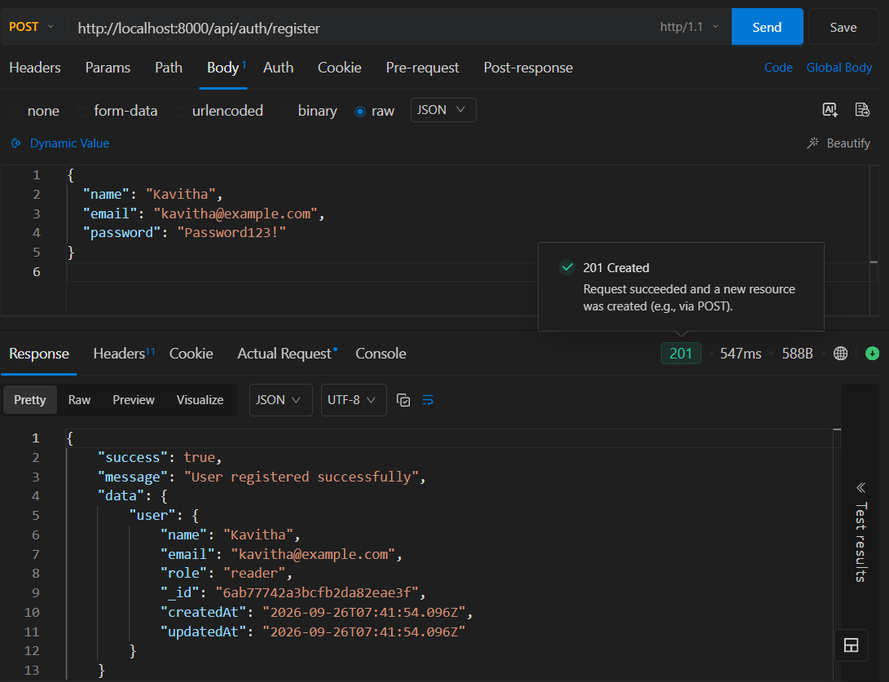
Figure 21: User registration
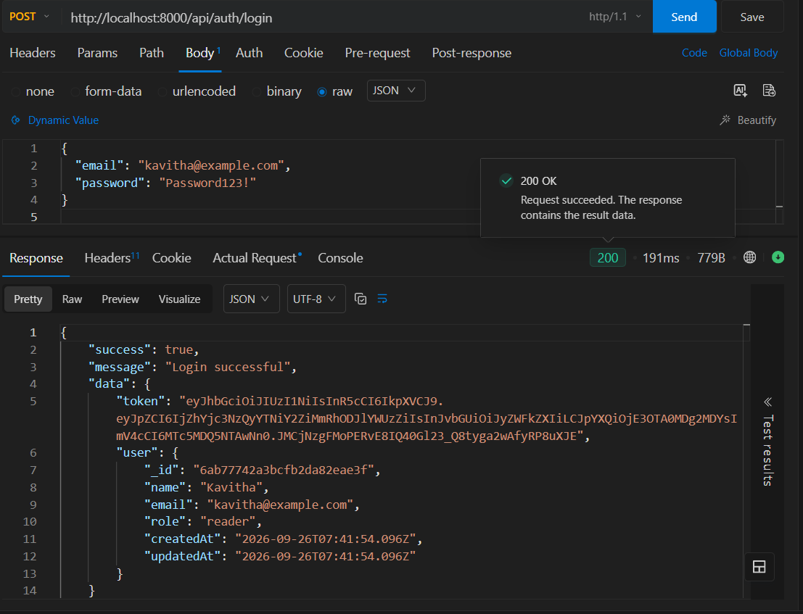
Figure 22: User login and JWT authentication

5. ROLE-BASED ACCESS CONTROL DEVELOPMENT
Four roles were implemented:
- Admin
- Editor
- Author
- Reader
Role-based middleware checks the authenticated user's role before performing restricted operations.
Examples:
- Authors can create and manage their own blogs.
- Editors can review and publish content.
- Administrators can manage users and system resources.
- Readers can access published blogs and comments.
The completed implementation includes reusable role middleware and ownership checks.

DEVELOPMENT EVIDENCE
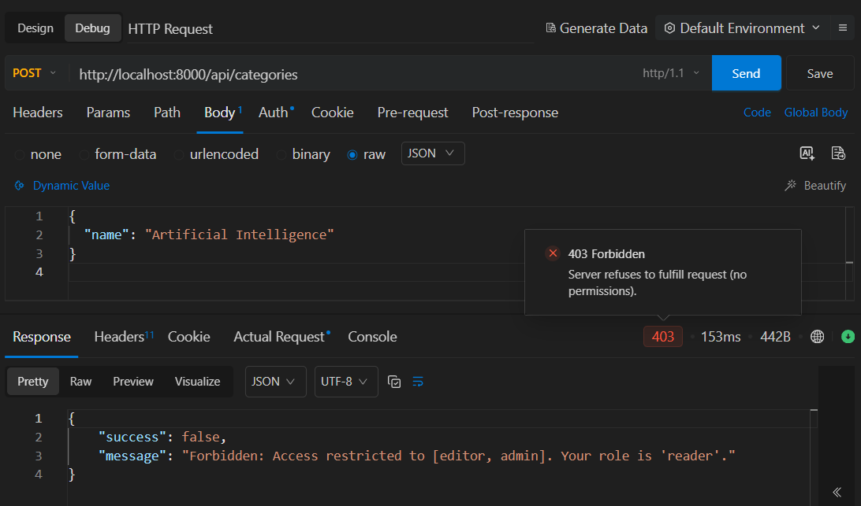

Figure 20: RBAC preventing unauthorized access

6. BLOG MANAGEMENT DEVELOPMENT
The Blog module was developed with complete CRUD operations.

APIs
POST /api/blogs
GET /api/blogs
GET /api/blogs/:id
PUT /api/blogs/:id
DELETE /api/blogs/:id
The module includes:
- Blog title and content
- Author reference
- Category
- Tags
- Likes
- Publication status
- Timestamps
- Ownership protection
The project supports blog lifecycle states including draft, pending, scheduled, and published.

DEVELOPMENT EVIDENCE
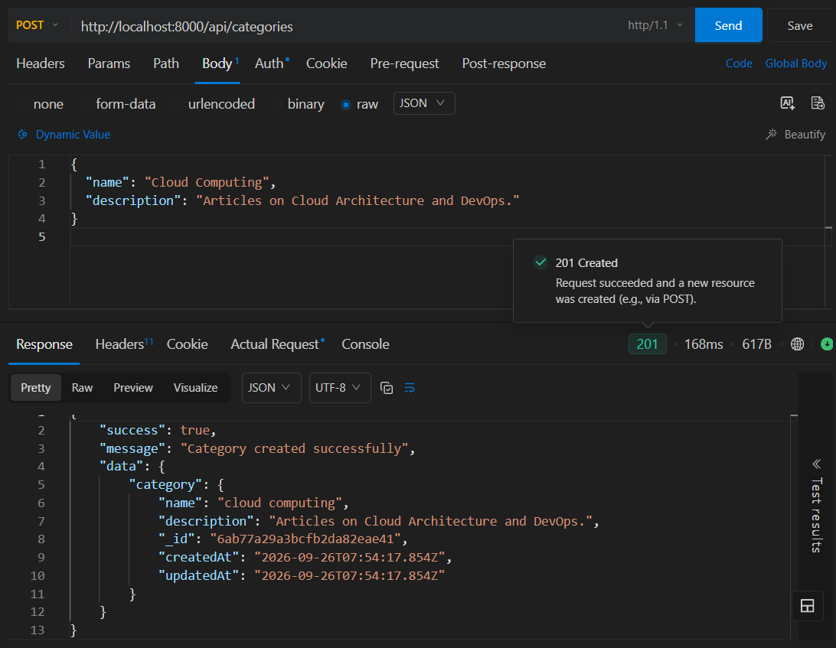
Figure 23: Creating a blog
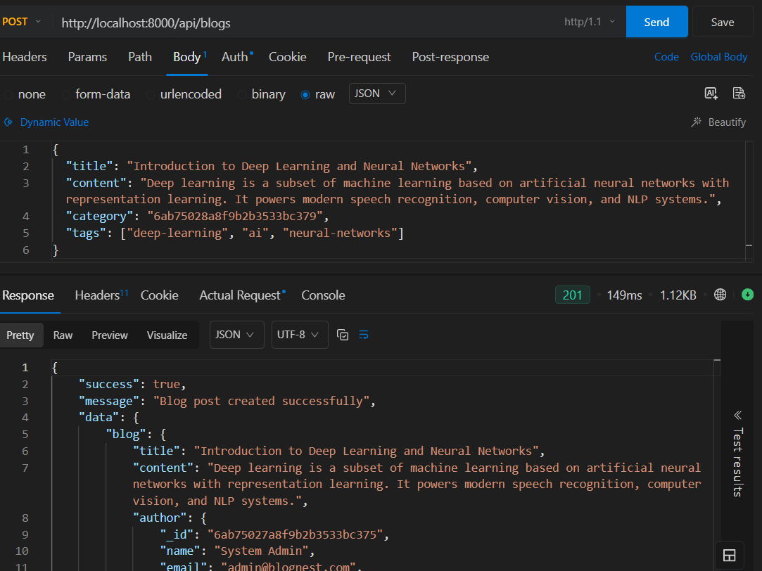
Figure 24: Retrieving blog posts
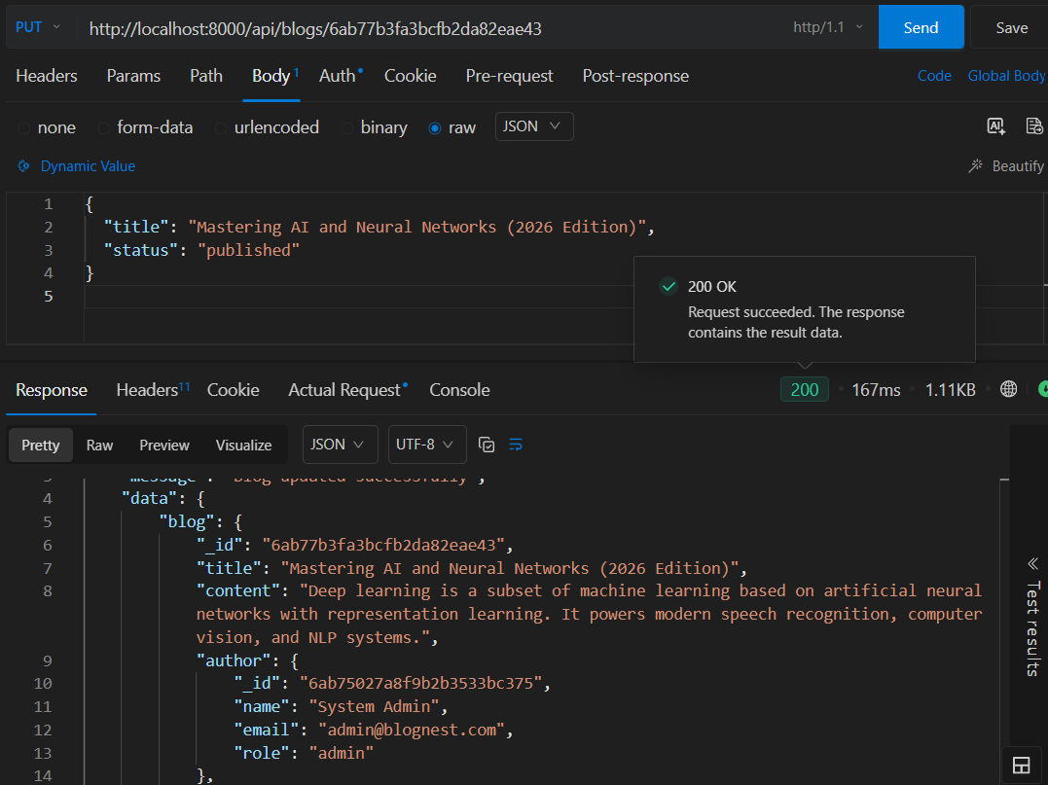
Figure 25: Updating a blog

7. CATEGORY DEVELOPMENT
The Category module was developed to organize blog content.

APIs
POST /api/categories
GET /api/categories
GET /api/categories/:id
PUT /api/categories/:id
DELETE /api/categories/:id
Category operations are protected according to user roles.
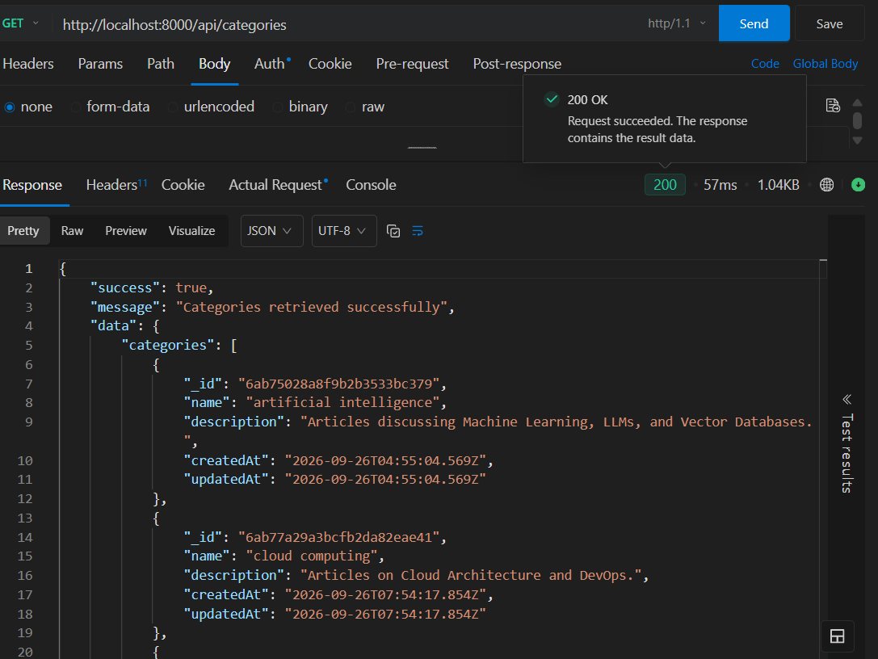
Figure 26: Category management

8. COMMENT DEVELOPMENT
The Comment module was developed for interaction and moderation.

APIs
POST /api/blogs/:blogId/comments
GET /api/blogs/:blogId/comments
PUT /api/comments/:id
DELETE /api/comments/:id
Comment statuses include:
- Pending
- Approved
- Spam
Authorized users can moderate comments.
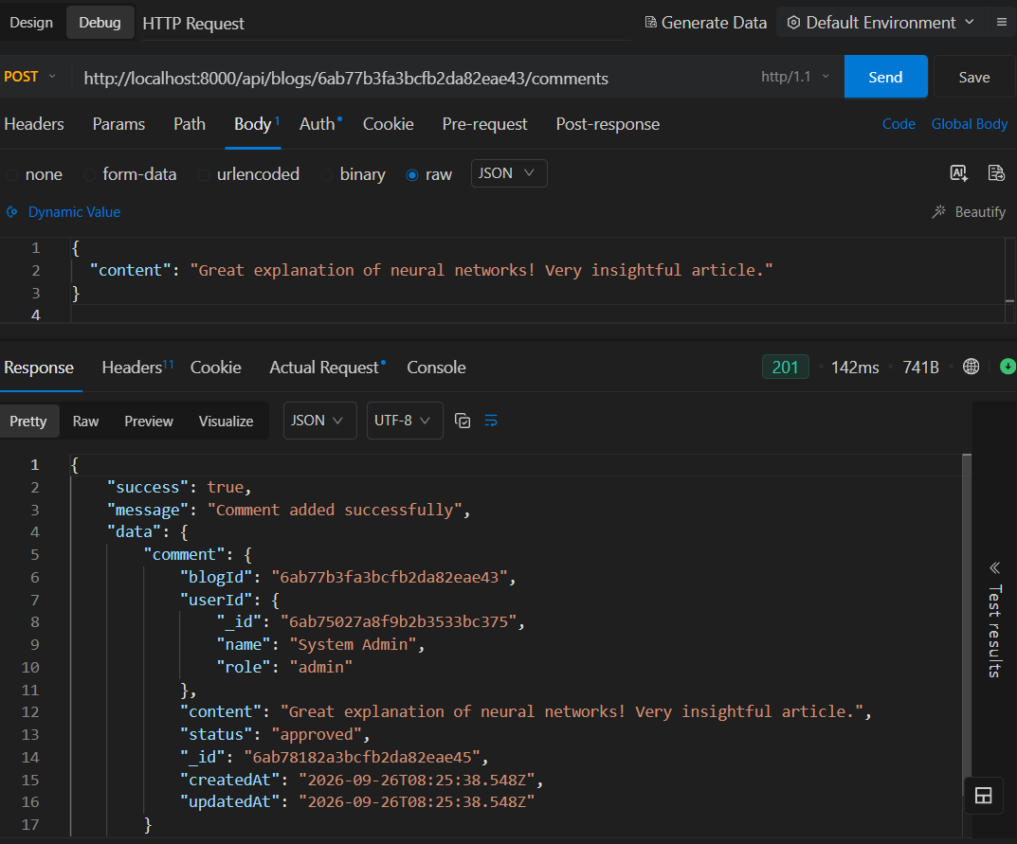
Figure 27: Creating a blog comment
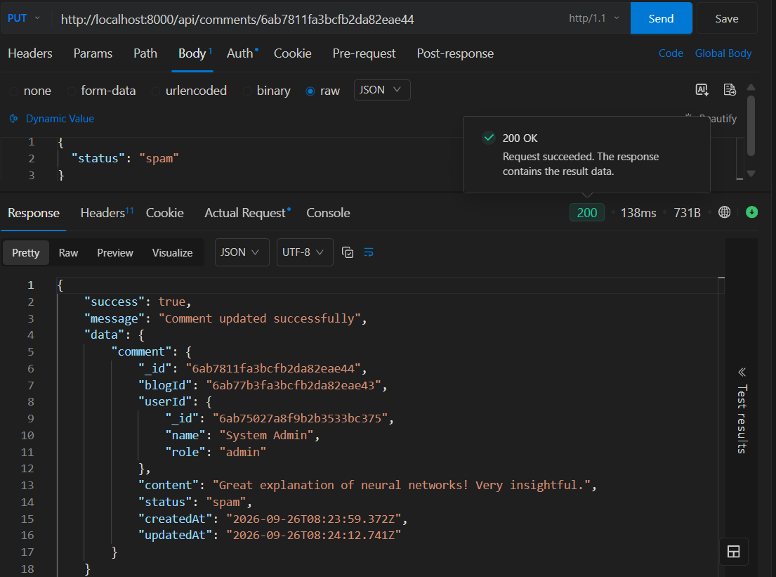
Figure 28: Comment moderation

9. GOOGLE GEMINI AI DEVELOPMENT
Google Gemini was integrated as the AI service for BlogNest.
The AI module provides:
- AI blog generation
- AI summarization

Blog Generation API
POST /api/ai/generate-blog

Summarization API
POST /api/ai/summarize
These are the AI endpoints defined in the BlogNest specification
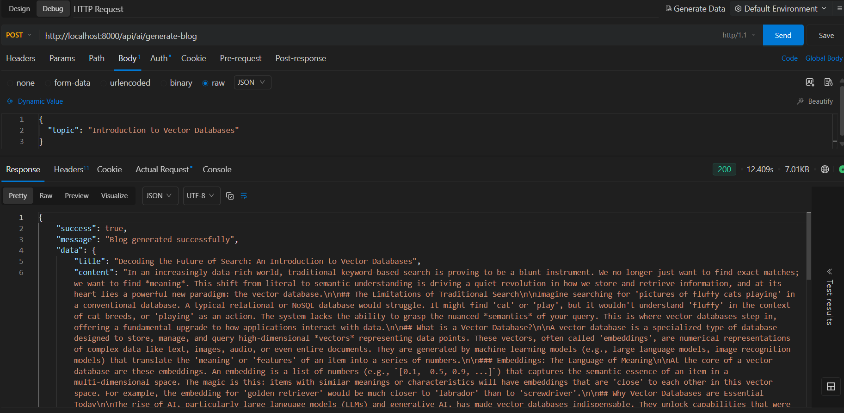
Figure 29: AI-powered blog generation using Google Gemini
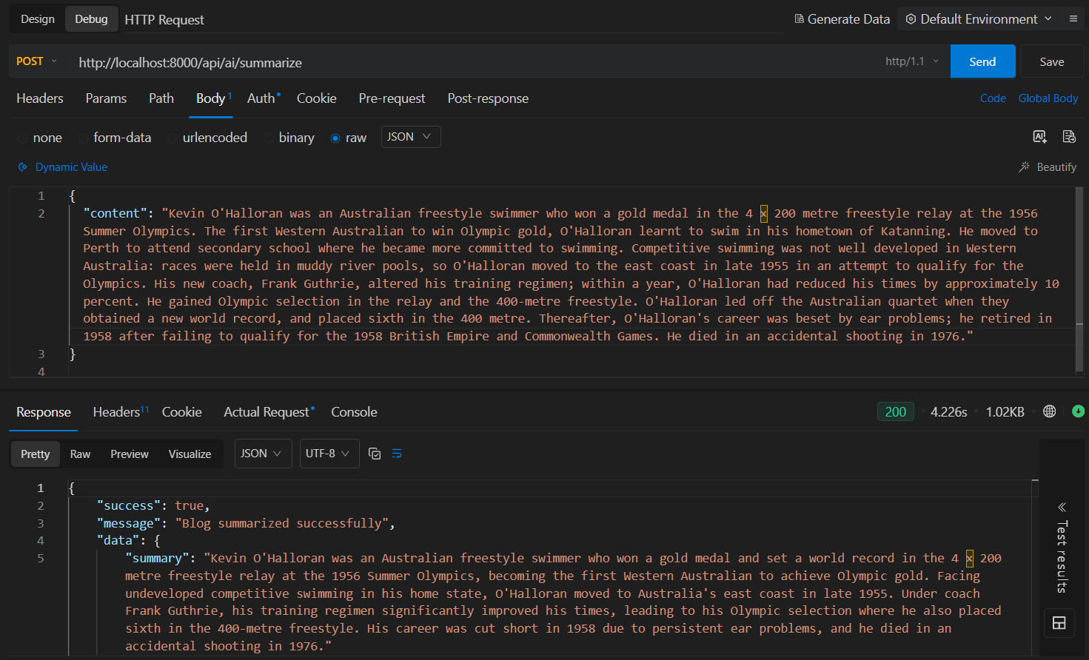
Figure 31: AI-powered blog summarization

10. PROMPT ENGINEERING DEVELOPMENT
Structured prompts were developed for the Gemini AI operations.
For blog generation, the prompt provides the topic and defines the expected structure of the generated content.
For summarization, the prompt provides the blog content and requests a concise summary.

Processing Flow
Topic
↓
Structured Prompt
↓
Google Gemini
↓
Generated Blog Content
.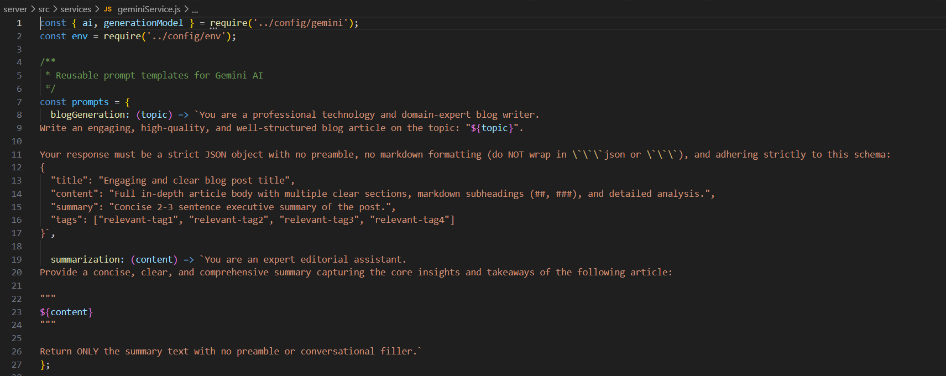
Figure 30: Prompt engineering for AI blog generation

11. MONGODB ATLAS SEARCH DEVELOPMENT
MongoDB Atlas Search was implemented for keyword-based blog search.

API
GET /api/search?q=<search-term>
The search operates on blog content such as titles, content, and tags.
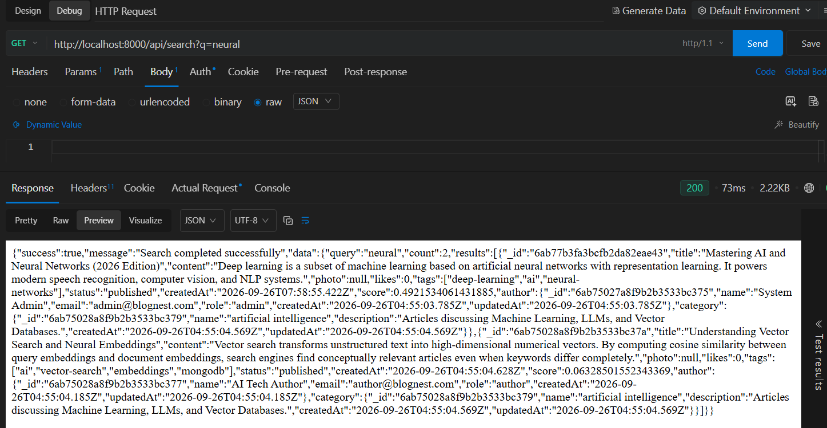
Figure 36: MongoDB Atlas Search result

12. MONGODB ATLAS VECTOR SEARCH DEVELOPMENT
Vector search was developed for semantic retrieval.
The system generates embeddings for blog content and stores the resulting vectors in the Embedding collection.
The vector search system uses MongoDB Atlas Vector Search to retrieve relevant content.

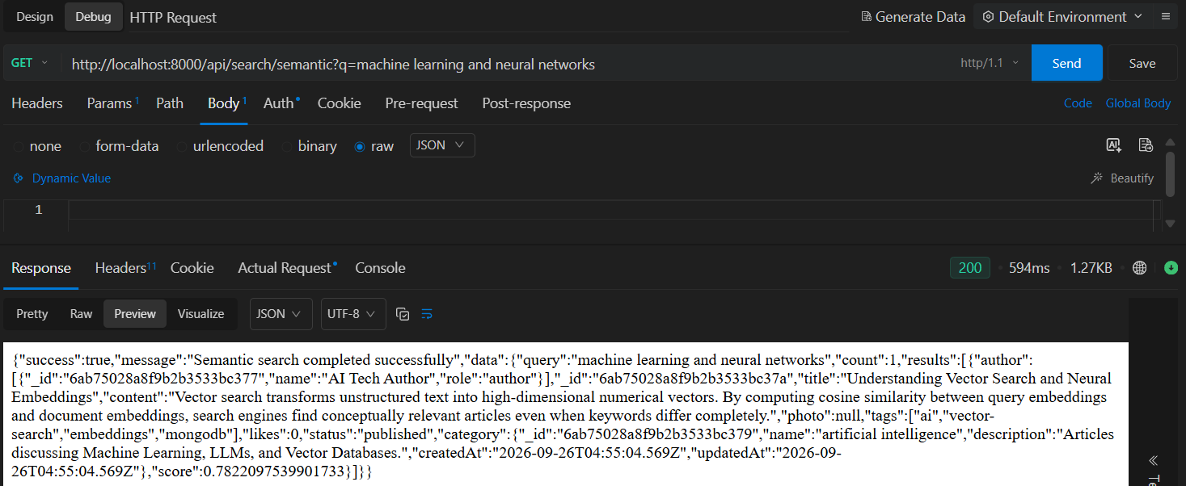Figure 35: search using vector embeddings

13. SECURITY DEVELOPMENT
The backend security layer was implemented using:
- bcrypt password hashing
- JWT authentication
- Role-based authorization
- Input validation
- Input sanitization
- Rate limiting
- Centralized error handling
- Sensitive-data protection
The completed implementation reports these security controls as part of the backend.

15. API TESTING DURING DEVELOPMENT
Each major module was tested during development rather than only after completion.
Testing covered:
- Registration
- Login
- Authentication
- RBAC
- Blog CRUD
- Categories
- Comments
- AI generation
- AI summarization
- Keyword search
- Semantic search
- Vector search
Postman/ Thunder Client / Echo API for VS Code was used for API-level testing.
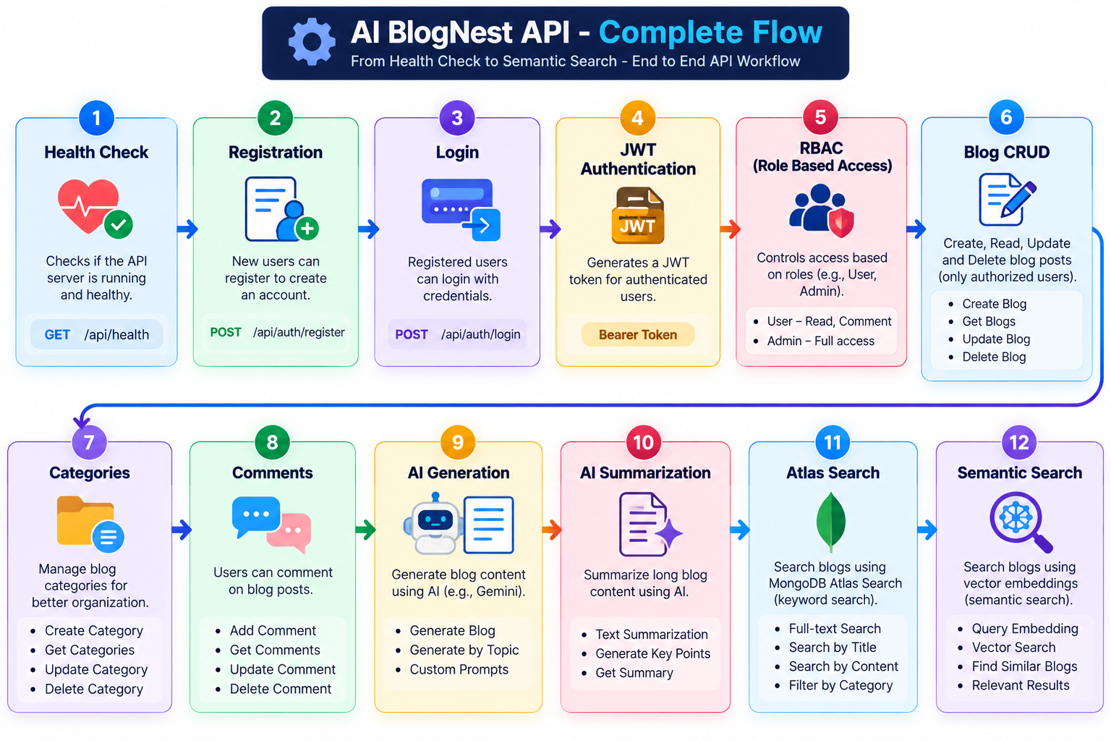

16. TESTING RESULTS
The completed testing verification tested authentication, roles, categories, blogs, comments, ownership protection, pagination, and filtering.
The reported result was:
25 Passed, 0 Failed.
For the final documentation, the latest overall project test result should be used.

17. MONGODB CONNECTION
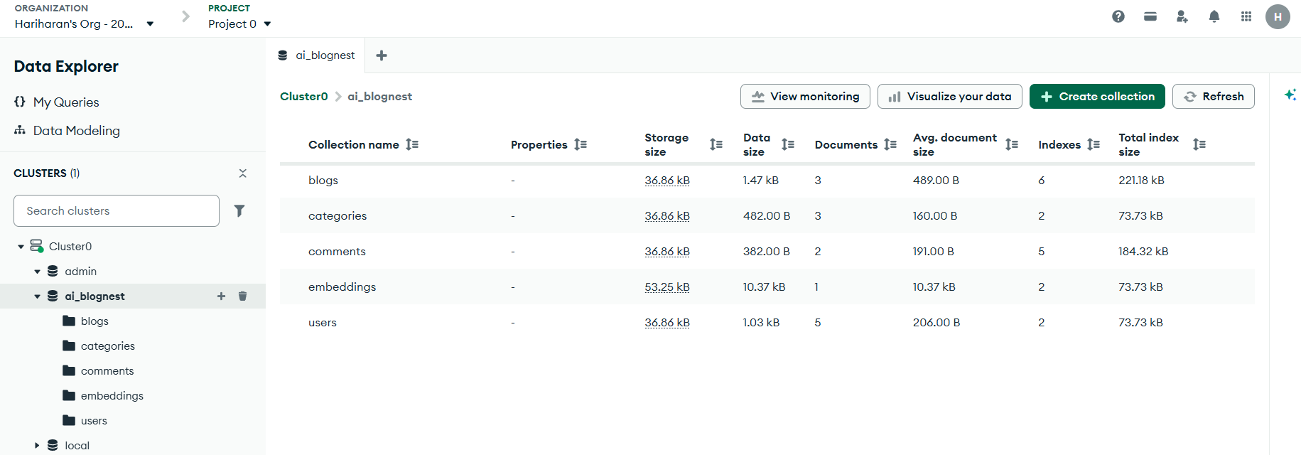

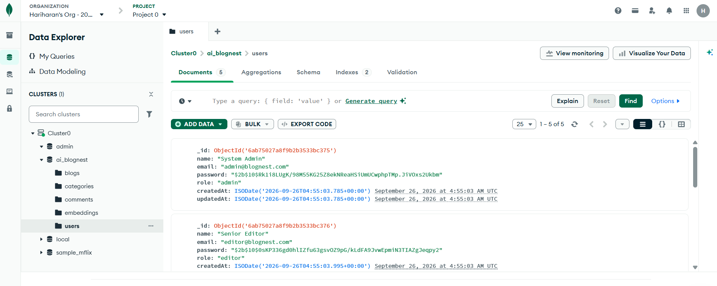

18. File Structure

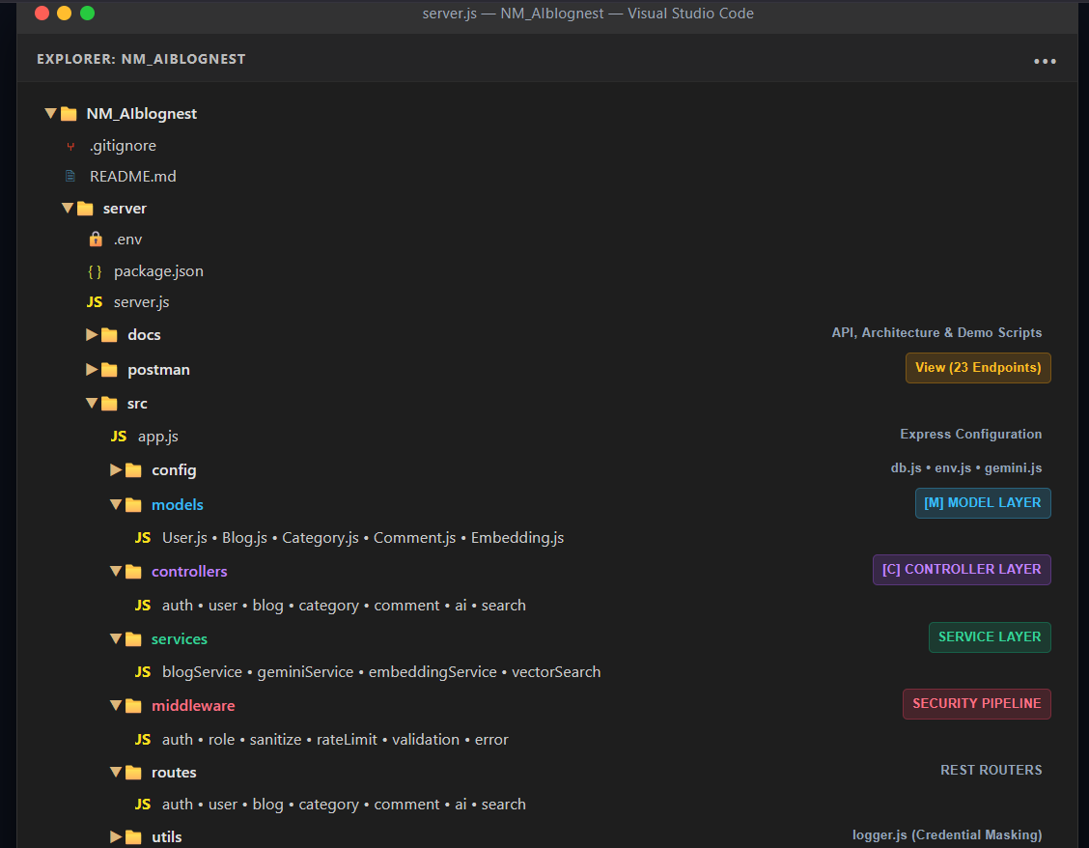

19. DEVELOPMENT OUTCOME
The development phase resulted in a functional backend REST API containing:
- Secure authentication
- Role-based authorization
- Blog CRUD
- Categories
- Comments and moderation
- Gemini AI integration
- Prompt engineering
- Atlas keyword search
- Atlas vector search
- Semantic search
- Security middleware
- Postman API testing

Conclusion
The Project Development Phase successfully transformed the AI BlogNest requirements and design into a functional backend REST API. The system was developed using Node.js, Express.js, MongoDB Atlas, Mongoose, JWT, bcryptjs, and Google Gemini AI. The implemented modules include user authentication, role-based access control, blog CRUD operations, category management, comment management and moderation, AI-powered blog generation and summarization, MongoDB Atlas Search, MongoDB Atlas Vector Search, and semantic search. The development followed a modular MVC-based structure with separate controllers, services, routes, models, and middleware. The completed implementation was tested through API and automated testing to verify the major project functionalities.

